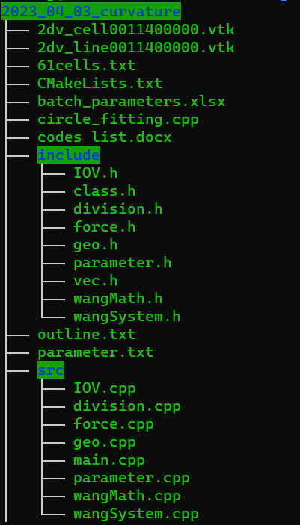

class:

1. Vertex; 2. Line; 3. Cell; 4. Organ; 5. Geometrics; 6. DivisionRecord; 7. Parameterlist; 8. Circle